Microsoft Azure - Starter Kits for Partners

Azure Assessment

Dev & Test Scenario

Last Update: September 2015





**MICROSOFT MAKES NO WARRANTIES, EXPRESS, IMPLIED OR STATUTORY, AS TO THE INFORMATION IN THIS DOCUMENT.**

The information contained in this document represents the current view of Microsoft Corporation on the issues discussed as of the date of publication. Because Microsoft must respond to changing market conditions, it should not be interpreted to be a commitment on the part of Microsoft, and Microsoft cannot guarantee the accuracy of any information presented after the date of publication.

Complying with all applicable copyright laws is the responsibility of the user. Without limiting the rights under copyright, no part of this document may be reproduced, stored in or introduced into a retrieval system, or transmitted in any form or by any means (electronic, mechanical, photocopying, recording, or otherwise), or for any purpose, without the express written permission of Microsoft Corporation.

Microsoft may have patents, patent applications, trademarks, copyrights, or other intellectual property rights covering subject matter in this document. Except as expressly provided in any written license agreement from Microsoft, the furnishing of this document does not give you any license to these patents, trademarks, copyrights, or other intellectual property.

The descriptions of other companies’ products in this document, if any, are provided only as a convenience to you. Any such references should not be considered an endorsement or support by Microsoft. Microsoft cannot guarantee their accuracy, and the products may change over time. Also, the descriptions are intended as brief highlights to aid understanding, rather than as thorough coverage. For authoritative descriptions of these products, please consult their respective manufacturers.

© 2014 Microsoft Corporation. All rights reserved. Any use or distribution of these materials without express authorization of Microsoft Corp. is strictly prohibited.

Microsoft and Windows are either registered trademarks of Microsoft Corporation in the United States and/or other countries.

The names of actual companies and products mentioned herein may be the trademarks of their respective owners.

Contents

Overview 5

Azure Scenario Assessment 6

Common Scenarios 6

Is Your Application a Good Fit for Azure? 8

Questions 10

Identity 10

Does your application require Microsoft Azure Active Directory? 10

Does your application require Active Directory in a Virtual Machine in Azure? 11

Are you considering other identity providers as Yahoo, Facebook, Google or Windows Live ID? 11

Application 11

Are you planning a Linux Virtual Machine? 11

Which software do you consider to execute in Microsoft Azure for development/test scenario? 12

Does your application require Biztalk Server 2013 in Virtual Machine? 12

Storage 12

Do you require NoSQL Storage (Table Storage)? 13

Do you require storage in Virtual Machines? 14

Do you require SQL Server in Virtual Machine? 14

Do you require SQL BI in Virtual Machines? 14

Does your application use Microsoft Azure SQL Database? 15

Does your application use Oracle Database? 15

Do you require Backups? 15

Infrastructure 15

Are you going to use Chef for Azure resource management capabilities? 15

Do you require scripting capabilities? 16

Are you going to use Visual Studio Online for Software Lifecycle on Azure Virtual Machines? 16

Are you going to use Team Foundation Server for Software Lifecycle on Azure Virtual Machines? 16

Hybrid Scenarios 16

Does your app need hybrid connection? 17

Do you need to extend your datacenter? 17

Do you use a VPN device? Do you use Software VPN, such as RRAS? 17

High Availability 17

Does your application require Session Affinity in your Web Application? 17

Does your application requires load balancing? 18

Does your application require High Availability in SQL Server? 18

Does your application require High Availability in Oracle? 18

Resources and Tools 18

Resources 18

Azure Readiness Content 18

http://www.microsoft.com/en-us/download/details.aspx?id=8396 18

Azure Technical Documentation Library 18

Patterns and Practices 18

Tools 19

VM Depot 19

http://azure.microsoft.com/es-es/blog/windows-azure-and-vm-depot-better-together/ 19

Azure Virtual Machine Readiness Assessment 19

http://azure.microsoft.com/en-us/downloads/vm-readiness-assessment/ 19

Microsoft Azure Virtual Machine Optimization Assessment 19

Technical FAQ 19

Azure Virtual Machines FAQ 19

Virtual Network FAQ 19

# Overview

The purpose of this document is to provide Microsoft Partners with an assessment to identify key components in the customer scenario and serve as a guide to the available resources. This will help the partner to build an efficient architecture for the customer scenario and have a correct cost proposal based in the customer needs.

In this document, we will cover the following topics:

* Common Scenarios
* Questionnaire
* Resources and Tools
* FAQ

# Azure Scenario Assessment

## Common Scenarios

You have the option to host web applications on Azure Cloud Services or Azure Virtual Machines. These options are good choices when your web tier requires the additional level of control and customization that they provide; however, this increased control comes at a cost of increased complexity in application creation, management, and deployment. The following diagram illustrates the trade-offs among the three options.

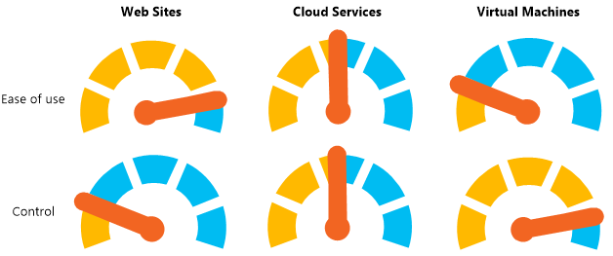

**I'm a small business owner, and I need an inexpensive way to host my site but with future growth in mind.**

Azure Web Sites (WAWS) is a great solution for this scenario, because you can start using it for free and then add more capabilities when you need them. For example, each free web site comes with a domain provided by Azure (*your_company*.azurewebsites.net). When you’re ready to start using your own domain, you can add this for as low as $9.80 a month (as of 1/2014). There are many other services and scaling options that allow the site to evolve with increased user demand. With Azure Web Sites, you can:

* Begin with the free tier and then scale up as needed.
* Use the Application Gallery to quickly setup popular web applications, such as WordPress.
* Add additional Azure services and features to your application as needed.
* Secure your web site with HTTPS using the certificate provided with your *your_company*.azurewebsites.net domain name.

**I'm a web or graphic designer, and I want to design and build web sites for my customers**

For web developers, Azure Web Sites gives you what you need to create sophisticated web applications. Web Sites offers tight integration with tools such as Visual Studio and SQL database. With Web Sites, developers can:

* Use command-line tools for [automated tasks](http://www.windowsazure.com/en-us/documentation/scripts/?services=web-sites).
* Work with popular languages such as [.Net](http://www.windowsazure.com/en-us/develop/net/), [PHP](http://www.windowsazure.com/en-us/develop/php/), [Node.js](http://www.windowsazure.com/en-us/develop/nodejs/), and [Python](http://www.windowsazure.com/en-us/develop/python/).
* Select three different scaling levels for scaling up to very high capacities.
* Integrate with other Azure services, such as [SQL Database](http://www.windowsazure.com/en-us/documentation/services/sql-database/), [Service Bus](http://www.windowsazure.com/en-us/documentation/services/service-bus/) and [Storage](http://www.windowsazure.com/en-us/documentation/services/storage/), or partner offerings from the [Azure Store](http://www.windowsazure.com/en-us/gallery/store/), such as MySQL and MongoDB.
* Integrate with tools, such as Visual Studio, Git, WebMatrix, WebDeploy, TFS, and FTP.

**I'm migrating my multi-tier application with a web front-end to the Cloud**

If you’re running a multi-tier application, such as a web server that talks to a database server to store and retrieve website data, you have several options in Azure. These architectural options include Web Apps, Cloud Services, and Virtual Machines. First, Web Apps is a good option for the web tier of your solution and can be used with Azure SQL Database to create a two-tier architecture. Web Apps also allows you to run background or long running processes using the Azure WebJobs SDK preview. If you need more complex architecture or more flexible scaling options, Cloud Services or Virtual Machines are a better choice.

**Cloud Services enables you to:**

* Host web, middle-tier, and backend services on scalable web and worker roles.
* Host only the middle-tier and backend services on worker roles, keeping the front-end on Azure Web Apps.
* Scale frontend and backend services independently.

**Virtual Machines enables you to:**

* Easily migrate highly customized environments as a virtual machine image.
* Run software or services that cannot be configured on Web Apps or Cloud Services.

**My application depends on highly customized Windows or Linux environments**

If your application requires complex installation or configuration of software and the operating system, Virtual Machines is probably the best solution. With Virtual Machines, you can:

* Use the Virtual Machine gallery to start with an operating system, such as Windows or Linux, and then customize it for your application requirements.
* Create and upload a custom image of an existing on-premises server to run on a virtual machine in Azure.

**My site uses open source software, and I want to host it in Azure**

All three options allow you to host open source languages and frameworks. Cloud Services requires you to use startup tasks to install and configure any required open source software that runs on Windows. With Virtual Machines, you install and configure the software on the machine image, which can be Windows or Linux-based. If your open source framework support is on Web Apps, this provides a simpler way to host these types of applications as Web Apps can be automatically configured with the languages and frameworks needed by your application. Web Apps enables you to:

* Use many popular open source languages, such as [.NET](http://www.windowsazure.com/en-us/develop/net/), [PHP](http://www.windowsazure.com/en-us/develop/php/), [Node.js](http://www.windowsazure.com/en-us/develop/nodejs/), and [Python](http://www.windowsazure.com/en-us/develop/python/).
* Setup WordPress, Drupal, Umbraco, DNN, and many other third-party web applications.
* Migrate an existing application or create a new one from the Application Gallery.

**I have a line-of-business application that needs to connect to the corporate network**

If you want to create a line-of-business application, your web site might require direct access to services or data on the corporate network. This is possible on Web Apps, Cloud Services, and Virtual Machines. There are differences in the approach you take, which include the following:

* Web Apps can securely connect to on-premises resources through the use of Service Bus Relay. This allows services on the corporate network to perform tasks on behalf of the web application without moving everything to the Cloud or setting up a virtual network.
* Cloud Services and Virtual Machines can take advantage of Virtual Network. Virtual Network allows machines running in Azure to connect to an on-premises network. Azure then becomes an extension of your corporate datacenter.

**I want to host a REST API or web service for mobile clients**

HTTP-based web services allows you to support a wide variety of clients, including mobile clients. Frameworks like the ASP.NET Web API integrate with Visual Studio to make it easier to create and consume REST services. These services are exposed from a web endpoint, so it is possible to use any web hosting technique on Azure to support this scenario. However, Web Apps is a great choice for hosting REST APIs. With Web Apps, you can:

* Quickly create a Web Site to host the HTTP web service in one of Azure´s globally distributed datacenters.
* Migrate existing services or create new ones, potentially taking advantage of the ASP.NET Web API in Visual Studio.
* Achieve SLA for availability with a single instance, or scale out to multiple dedicated machines.
* Use the published site to provide REST APIs to any HTTP clients, including mobile clients.

## Is Your Application a Good Fit for Azure?

If you're considering using Azure to host an application, you might wonder if the platform serves your application or business requirements. You can host most applications and machines on Azure. However, some scenarios take better advantage of the benefits of running in the Cloud.

|  |  |
| --- | --- |
| Area | Description |
| IaaS or PaaS? | Infrastructure as a Service (IaaS) allows you to put your own images on Virtual Machines. This is often a simpler way to migrate to the Cloud because it involves fewer changes to the application architecture.  Web Apps and Cloud Services provide Platform as a Service (PaaS). Applications you design for a PaaS environment are often more flexible, scalable, and manageable than similar solutions on IaaS. However, it typically takes more time to complete a migration to Cloud Services. Web Apps provides a good balance between PaaS’ advantages and IaaS’ ease of migration.  To better understand these options from a Web perspective, see [Azure Web Apps, Cloud Services and Virtual Machines comparison](http://go.microsoft.com/fwlink/?LinkId=392747). |
| Hybrid Solutions | It can be difficult to move complex legacy applications to Azure. There are also sometimes regulatory concerns with storing certain types of data in the Cloud. Some answers about security and regulatory compliance are addressed in the [Azure Trust Center](http://go.microsoft.com/fwlink/?LinkId=393274).  To meet these challenges, one solution is to create a hybrid application that connects hosted services with on-premises applications and data. There are multiple technologies that support this capability, including [Service Bus](http://go.microsoft.com/fwlink/?LinkId=392741) and [Virtual Network](http://go.microsoft.com/fwlink/?LinkId=392742). For more information, see [Building Hybrid Applications in the Cloud on Azure](http://go.microsoft.com/fwlink/?LinkId=392748). |
| State Management | If you are moving an existing application to Virtual Machines, you can typically handle state data in the same way that you did on-premises. However, if you want to take advantage of the PaaS architecture of Cloud Services, you must evaluate how you handle state. Many on-premises applications store state locally on the hard drive. Other features, such as the default ASP.NET session state, use the memory of the local machine for state management. Although cloud service roles have access to their virtual machine's local drive space and memory, load balances all requests across all role instances. Additionally, your role instance could be taken down and moved at any time (for example, when the machine running the role instance requires an update).  This dynamic management of working role instances is important for the scalability and availability features of Cloud Services. Consequently, you must design application code in the Cloud to store data and state remotely using services such as storage or Azure SQL Database. For more information about storage options, see the resources in the [Store and Access Data](http://go.microsoft.com/fwlink/?LinkId=235876). |
| Storage Requirements | Azure SQL Database is the relational database solution in Azure. If you currently use SQL Server, the transition to Azure SQL Database should be easier. You can also choose to run SQL Server on a Virtual Machine. If you are using a different database system, one option is to migrate to Azure SQL Database or SQL Server on a Virtual Machine. There are SQL Server Migration Assistants that can help with this process. For more information on migrating data to Azure SQL Database, see [Migrating a database to Azure SQL Database](https://azure.microsoft.com/en-us/documentation/articles/sql-database-cloud-migrate/). Another option is to migrate your third-party database directly to Azure. One technique is to install your database system on a Virtual Machine. However, there are also third-party offerings in the [Azure Store](http://go.microsoft.com/fwlink/?LinkId=393275) for systems like MySQL and MongoDB.  Also consider storage for durable, highly available, and scalable data storage. One good design pattern is to effectively combine the use of Azure SQL Database and storage tables, queues, and blobs. A common example is to use Azure SQL Database to store a pointer to a blob in storage. You do this instead of storing the large binary object in the database itself. This is efficient and cost-effective. |
| Interoperability | The SDK and tools for Visual Studio greatly simplify the process of creating or migrating .NET applications to Azure.  But what if you are using open source software or third-party development languages and tools? Web Sites and Cloud Services support applications written in Node.js, PHP, Python, and Java (for Cloud Services only). If your application uses another language, consider a Virtual Machine. When working with services, all operations are based on a REST API. You can directly code for this. However, provides official SDKs for Java, Node.js, PHP, Python, and Ruby that provide friendly wrappers around the REST API. There are also community-created SDKs that interact with Azure.  Of course, there are some challenges to address depending on your technology. For Virtual Machines, you must install the necessary runtimes and dependencies on your machine image. For Cloud Services, you may need to add a custom startup action to install the third-party dependencies for your role. For Web Apps, you may need to make minor modifications to allow the application to work in a PaaS hosting environment. A great resource in this area is the [Interoperability Bridges and Labs Center](http://go.microsoft.com/fwlink/?LinkID=236380).  The important point is that is accessible from a variety of languages. Therefore, you should look into the options for your particular language of choice before deciding if the application is a good candidate. |

# Questions

## Identity

|  |  |  |
| --- | --- | --- |
| Question | Answer | Read more |
| 1. Does your application require Microsoft Azure Active Directory? |  | * Developing ASP.NET Apps with Microsoft Azure Active Directory |
| 1. Does your application require Active Directory in a Virtual Machine in Azure? |  | * Guidelines for Deploying Windows Server Active Directory on Azure Virtual Machines |
| 1. Are you going to use other identity providers as Yahoo, Facebook, Google or Windows Live ID? |  | * ACS Overview |
| 1. What is your application Authentication method? | * LDAP * Windows Integrated * Database * Claims * Azure Active Directory * Other |  |

### Does your application require Microsoft Azure Active Directory?

#### Developing ASP.NET Apps with Microsoft Azure Active Directory

Microsoft ASP.NET tools for Microsoft Azure Active Directory makes it simple to enable authentication for web applications hosted on Microsoft Azure Web Sites. You can use Microsoft Azure Authentication to authenticate Office 365 users from your organization, corporate accounts synced from your on premise Active Directory or users created in your own custom Microsoft Azure Active Directory domain. Enabling Microsoft Azure Authentication configures your application to authenticate users using a single Microsoft Azure Active Directory tenant.

<http://www.asp.net/identity/overview/getting-started/developing-aspnet-apps-with-windows-azure-active-directory>

### Does your application require Active Directory in a Virtual Machine in Azure?

#### Guidelines for Deploying Windows Server Active Directory on Azure Virtual Machines

The paper explains the important differences between deploying Windows Server Active Directory Domain Services (AD DS) and Active Directory Federation Services (AD FS) on-premises versus deploying them on Microsoft Azure Virtual Machines (VMs).

<http://msdn.microsoft.com/en-us/library/azure/jj156090.aspx>

### Are you considering other identity providers as Yahoo, Facebook, Google or Windows Live ID?

#### ACS Overview

Microsoft Azure Active Directory Access Control (also known as Access Control Service or ACS) is a cloud-based service that provides an easy way of authenticating and authorizing users to gain access to your web applications and services while allowing the features of authentication and authorization to be factored out of your code. Instead of implementing an authentication system with user accounts that are specific to your application, you can let ACS orchestrate the authentication and much of the authorization of your users. ACS integrates with standards-based identity providers, including enterprise directories such as Active Directory, and web identities such as Windows Live ID (Microsoft account), Google, Yahoo!, and Facebook.

## Application

|  |  |  |
| --- | --- | --- |
| Question | Answer | Read more |
| 1. Are you planning a Linux Virtual Machine? |  | * Linux on Azure-Endorsed Distributions |
| 1. Which software do you consider to execute in Microsoft Azure for development/test scenario? |  | * Microsoft server software support for Microsoft Azure virtual machines |
| 1. Does your application require Biztalk Server 2013 in Virtual Machine? |  | * Configuring BizTalk Server 2013 on an Azure VM |

### Are you planning a Linux Virtual Machine?

#### Linux on Azure-Endorsed Distributions

The following table shows the different distribution versions, Linux Integration Services (LIS) drivers and Azure Linux Agent versions that have been tested to work on Azure.

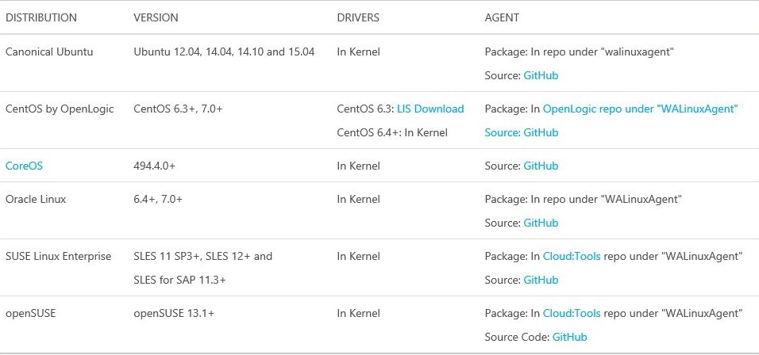

<http://azure.microsoft.com/en-us/documentation/articles/virtual-machines-linux-endorsed-distributions/>

### Which software do you consider to execute in Microsoft Azure for development/test scenario?

#### Microsoft server software support for Microsoft Azure virtual machines

This article discusses the support policy for running Microsoft server software in the Microsoft Azure virtual machine environment (infrastructure-as-a-service).

<http://support.microsoft.com/kb/2721672>

### Does your application require Biztalk Server 2013 in Virtual Machine?

#### Configuring BizTalk Server 2013 on an Azure VM

BizTalk Server 2013 is now available on Microsoft Azure. BizTalk Server 2013 can be installed locally on your hardware and in Azure as a virtual machine.

<http://msdn.microsoft.com/en-us/library/azure/jj248689.aspx>

## Storage

|  |  |  |
| --- | --- | --- |
| Question | Answer | Read more |
| 1. Which database are you going to use? | * SQL Database * SQL Server in Virtual Machine * Oracle in Virtual Machine * Other |  |
| 1. Do you require NoSQL Storage (Table Storage)? |  | * **Azure Table Storage and Microsoft Azure SQL Database - Compared and Contrasted** |
| 1. Do you require storage in Virtual Machines? |  | * **About Virtual Machine Disks in Azure** |
| 1. How much data would be migrated? | * 1 TB or less * 16 TB or less * 500 TB or less * More than 500 TB | * [**Import/Export – Not available in all regions**](http://azure.microsoft.com/en-us/documentation/articles/storage-import-export-service/) * [**AzCopy Command-Line Utility**](http://azure.microsoft.com/en-us/documentation/articles/storage-use-azcopy/) |
| 1. Do you require SQL Server in Virtual Machine? |  | * **SQL Server in Azure Virtual Machines** |
| 1. Do you require SQL BI in Virtual Machines? |  | * **SQL Server Business Intelligence in Azure Virtual Machines** |
| 1. Will your application use Microsoft Azure SQL Database? |  | * **Azure SQL Database Guidelines and Limitations** |
| 1. Will your application use Oracle Database? |  | * **List of Oracle Virtual Machine Images** |
| 1. Do you require Backups? |  | * **Backup** |

### Do you require NoSQL Storage (Table Storage)?

#### Table Service Concepts

You can use the Table service API to create tables for structured storage, and to insert, update, delete, and query data.

<http://msdn.microsoft.com/en-us/library/dd179463.aspx>

#### Azure Table Storage and Microsoft Azure SQL Database - Compared and Contrasted

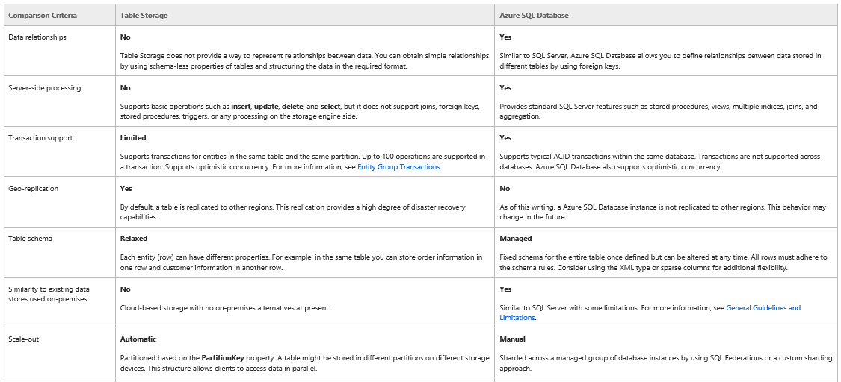

<http://msdn.microsoft.com/en-us/library/jj553018.aspx>

### Do you require storage in Virtual Machines?

#### About Virtual Machine Disks in Azure

Just like any other computer, virtual machines in Azure use disks as a place to store an operating system, applications, and data.

All Azure virtual machines have at least two disks – an operating system disk and a temporary disk. They also can have one or more data disks. The following diagram shows how these three types of disks appear from within a Windows virtual machine.

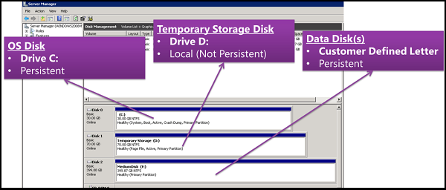

<http://msdn.microsoft.com/en-us/library/dn790303.aspx>

### Do you require SQL Server in Virtual Machine?

#### SQL Server in Azure Virtual Machines

Azure Virtual Machine enables you to create a server in the cloud that you can control and manage. Whether you build a new application with SQL Server in the cloud or migrate an existing application into the cloud as-is, Azure Virtual Machines is a robust infrastructure for SQL Server. By using Azure as a hosting environment for your SQL Server virtual machines, you can reduce the total cost of ownership of deployment, management, and maintenance of your enterprise database applications.

<https://azure.microsoft.com/en-us/documentation/articles/virtual-machines-sql-server-infrastructure-services/>

#### Getting Ready to Migrate to SQL Server in Azure Virtual Machines

This topic provides guidelines and recommendations on migration to SQL Server in Azure Virtual Machines.

<https://azure.microsoft.com/es-es/documentation/articles/virtual-machines-migrate-onpremises-database/>

### Do you require SQL BI in Virtual Machines?

#### SQL Server Business Intelligence in Azure Virtual Machines

The Microsoft Azure Virtual Machine gallery includes images that contain SQL Server installations. The SQL Server editions supported in the gallery images are the same installation files you can install to on-premises computers and virtual machines. This topic summarizes the SQL Server Business Intelligence (BI) Features installed on the images and configuration steps required after a virtual machine is provisioned. This topic also describes supported deployment topologies for BI features and best practices.

<https://azure.microsoft.com/es-es/documentation/articles/virtual-machines-sql-server-business-intelligence/?rnd=1>

### Does your application use Microsoft Azure SQL Database?

#### Azure SQL Database Guidelines and Limitations

This section describes the guidelines and limitations that are important to consider when using Microsoft Azure SQL Database.

<http://msdn.microsoft.com/en-us/library/ff394102.aspx>

### Does your application use Oracle Database?

#### List of Oracle Virtual Machine Images

The following is a list of the available Oracle virtual machine images that target Windows Server on Microsoft Azure.

<https://azure.microsoft.com/es-es/documentation/articles/virtual-machines-oracle-list-oracle-virtual-machine-images/>

### Do you require Backups?

#### Backup

Azure Backup can help you protect important server data offsite with automated backups to Azure, where they are available for easy data restoration. You can manage cloud backups from the familiar backup tools in Windows Server 2012, Windows Server 2012 Essentials, or System Center 2012 - Data Protection Manager. These tools provide similar experiences for configuring, monitoring, and recovering backups, whether to a local disk or to cloud storage. After data is backed up to the cloud, authorized users can easily recover backups to any server.

## Infrastructure

|  |  |  |
| --- | --- | --- |
| Question | Answer | Read more |
| 1. Are you going to use Chef for Azure resource management capabilities? |  | * **Using Chef to Manage Microsoft Azure Resources** |
| 1. Do you require scripting capabilities? |  | * **Azure PowerShell** |
| 1. Are you going to use Visual Studio Online for Software Lifecycle? |  | * **What is Visual Studio Online?** |
| 1. Are you going to use Team Foundation Server for Software Lifecycle on Azure Virtual Machines? |  | * **Run Team Foundation Server (TFS) on Azure Virtual Machines** |

### Are you going to use Chef for Azure resource management capabilities?

#### Using Chef to Manage Microsoft Azure Resources

Chef is an open source DevOps tool built to address hard IT infrastructure challenges. The team at Microsoft Open Technologies Inc. (MS Open Tech) has been hard at work collaborating with Chef the company to enhance Microsoft Azure resource management capabilities. The latest knife-azure release (v1.2.2) brings a number of bug fixes and some important new features to Chef that focus on provisioning and managing optimized clusters of virtual machines and other Microsoft Azure resources.

<http://blogs.msdn.com/b/interoperability/archive/2014/03/07/using-chefs-knives-to-manage-windows-azure-resources.aspx>

### Do you require scripting capabilities?

#### Azure PowerShell

Azure PowerShell is a powerful scripting environment that you can use to control and automate the deployment and management of your workloads in Azure. Whether you are experienced with Windows PowerShell or a new user, instructions are available to help you get started provisioning virtual machines, setting up virtual networks and cross-premises networks, and managing cloud services in Azure.

<http://msdn.microsoft.com/en-us/library/azure/jj156055.aspx>

### Are you going to use Visual Studio Online for Software Lifecycle on Azure Virtual Machines?

#### What is Visual Studio Online?

Visual Studio Online is the fastest and easiest way yet to plan, build, and ship software across a variety of platforms. Get up and running in minutes on our cloud infrastructure without having to install or configure a single server.

<http://azure.microsoft.com/en-us/services/visual-studio-online/>

### Are you going to use Team Foundation Server for Software Lifecycle on Azure Virtual Machines?

#### Run Team Foundation Server (TFS) on Azure Virtual Machines

While Visual Studio Online looks similar to TFS on-premises from a user’s perspective, customization support is limited, creating a barrier for organizations that have customized processes. Other organizations might have barriers to using a public service, preferring to keep themselves on a private cloud. If you have customized processes, or need integration with other software not currently offered by Visual Studio Online, or just want to explore the possibilities of deploying TFS on a private cloud, this guidance delivers practical, scenario-based guidance for the implementation of Team Foundation Server (TFS) on Azure Infrastructure as a Service (IaaS). It guides you through the planning and decisions, based on a real-world proof-of-concept production deployment and experience from the ALM Rangers.

<http://msdn.microsoft.com/en-us/library/azure/dn769056.aspx>

## Hybrid Scenarios

|  |  |  |
| --- | --- | --- |
| Question | Answer | Read more |
| 1. Does your app need hybrid connection? |  | * **Hybrid Connections Overview** |
| 1. Do you need to extend your datacenter? |  | * **Virtual Network Overview** |
| 1. Do you use a VPN device? Do you use Software VPN, such as RRAS? |  | * **About VPN Devices for Virtual Network** |

### Does your app need hybrid connection?

#### Hybrid Connections Overview

Hybrid Connections provides an easy and convenient way to connect Azure Websites and Azure Mobile Services to on-premises resources. Hybrid Connections are a feature of Azure BizTalk Services.

<http://azure.microsoft.com/en-us/documentation/articles/integration-hybrid-connection-overview/>

### Do you need to extend your datacenter?

#### Virtual Network Overview

Microsoft Azure Virtual Network provides you with the capability to extend your network into Microsoft Azure and treat deployments in Windows as a natural extension to your on-premises network.

<https://azure.microsoft.com/en-us/documentation/articles/virtual-networks-overview/>

### Do you use a VPN device? Do you use Software VPN, such as RRAS?

#### About VPN Devices for Virtual Network

A secure site-to-site VPN connection can be used to create a branch office solution or whenever you want a secure connection between your on-premises network and your virtual network. Site-to-site connections require a public-facing IPv4 IP address and a compatible VPN device or RRAS running on Windows Server 2012.

<http://msdn.microsoft.com/en-us/library/azure/jj156075.aspx>

## High Availability

|  |  |  |
| --- | --- | --- |
| Question | Answer | Read more |
| 1. Does your application require Session Affinity in your Web Application? |  | * **How to Use ASP.NET Session State with Azure Websites** |
| 1. Does your application require load balancing? |  | * **Azure Load Balancer** |
| 1. Does your application require High Availability in SQL Server? |  | * **High Availability and Disaster Recovery for SQL Server in Azure Virtual Machines** |
| 1. Does your application require High Availability in Oracle? |  | * **Configuring Oracle Data Guard for Azure** |

### Does your application require Session Affinity in your Web Application?

#### How to Use ASP.NET Session State with Azure Websites

This topic explains how to use the Azure Redis Cache Service (Preview) for session state.

If your ASP.NET web app uses session state, you will need to configure an external session state provider (either the Redis Cache Service or a SQL Server session state provider). If you use session state, and don't use an external provider, you will be limited to one instance of your web app. The Redis Cache Service is the fastest and simplest to enable.

<http://azure.microsoft.com/en-us/documentation/articles/web-sites-dotnet-session-state-caching/>

### Does your application requires load balancing?

#### Azure Load Balancer

<https://azure.microsoft.com/en-us/documentation/articles/load-balancer-overview/>

### Does your application require High Availability in SQL Server?

#### High Availability and Disaster Recovery for SQL Server in Azure Virtual Machines

Microsoft Azure virtual machines (VMs) with SQL Server can help lower the cost of a high availability and disaster recovery (HADR) database solution. Most SQL Server HADR solutions are supported in Azure virtual machines, both as Azure-only and as hybrid solutions. In an Azure-only solution, the entire HADR system runs in Azure. In a hybrid configuration, part of the solution runs in Azure and the other part runs on-premises in your organization. The flexibility of the Azure environment enables you to move partially or completely to Azure to satisfy the budget and HADR requirements of your SQL Server database systems.

<https://azure.microsoft.com/es-es/documentation/articles/virtual-machines-sql-server-high-availability-and-disaster-recovery-solutions/?rnd=1>

### Does your application require High Availability in Oracle?

#### Configuring Oracle Data Guard for Azure

This tutorial demonstrates how to setup and implement Oracle Data Guard in Azure Virtual Machines environment for high availability and disaster recovery. The tutorial focuses on one way replication for non-RAC Oracle databases.

<https://azure.microsoft.com/en-us/documentation/articles/virtual-machines-configuring-oracle-data-guard/>

# Resources and Tools

## Resources

### Azure Readiness Content

The Azure Readiness Content provides a set of presentations and demos designed to help learn the latest Microsoft Azure features and services.

### <http://www.microsoft.com/en-us/download/details.aspx?id=8396>

### Azure Technical Documentation Library

Looking for Microsoft’s technical documentation library for Microsoft Azure services? You’ve found the right place! You’ll find in-depth content that can help you get the most value from Microsoft Azure.

<http://msdn.microsoft.com/en-us/library/azure/dn578280.aspx>

### Patterns and Practices

* [Cloud Design Patterns](http://msdn.microsoft.com/en-us/library/dn568099.aspx)
* [Developing big data solutions on Microsoft Azure HDInsight](http://msdn.microsoft.com/en-us/library/dn749874.aspx)
* [Building an On-Demand Video Service with Microsoft Azure Media Services](http://msdn.microsoft.com/en-us/library/dn735912.aspx)
* [Moving Applications to the Cloud, Third Edition](http://msdn.microsoft.com/en-us/library/ff728592.aspx) on Microsoft Azure
* [Developing Multi-tenant Applications for the Cloud, Third Edition](http://msdn.microsoft.com/en-us/library/ff966499.aspx) on Microsoft Azure
* [Building Hybrid Applications in the Cloud](http://msdn.microsoft.com/en-us/library/hh871440.aspx) on Microsoft Azure
* [Enterprise Library 5.0 Integration Pack for Microsoft Azure](http://msdn.microsoft.com/en-us/library/hh680918(v=pandp.50).aspx)

## Tools

### VM Depot

VM Depot is a community-driven catalog of preconfigured operating systems, applications, and development stacks that can be deployed on Microsoft Azure. These images are provided and licensed to you by community members. Microsoft Open Technologies, Inc. does not screen these images for security, compatibility, or performance, and does not provide any license rights or support for them. By using unsupported images, you might forfeit Microsoft Azure availability SLA.

### <http://azure.microsoft.com/es-es/blog/windows-azure-and-vm-depot-better-together/>

### Azure Virtual Machine Readiness Assessment

The Virtual Machines Readiness Assessment tool will automatically inspect your on-premises environment, whether it is physical or virtualized, and provide you with a check list and detailed report on steps you need to take to move your environment to the cloud.

### <http://azure.microsoft.com/en-us/downloads/vm-readiness-assessment/>

### Microsoft Azure Virtual Machine Optimization Assessment

The Microsoft Azure Virtual Machine Optimization Assessment tool will automatically inspect your Virtual Machines running in Microsoft Azure. Optimize your investment in Azure with the prioritized recommendations provided.

<http://www.microsoft.com/en-us/download/details.aspx?id=43377>

# Technical FAQ

## Azure Virtual Machines FAQ

<https://azure.microsoft.com/en-us/documentation/articles/virtual-machines-questions/>

## Virtual Network FAQ

<https://azure.microsoft.com/en-us/documentation/articles/virtual-networks-faq/>